STRATEGIC PLANNING

Definition
Strategic planning is the process by which the guiding members of an organization envision its future and develop the necessary procedures and operations to achieve that future. What do you want to accomplish, how do you know if you are successful?
A strategic plan is the management tool and documentation of the strategy chosen as a result of strategic planning.

Why should organizations create a strategic plan?
- To provide a framework for action
- To set goals
- To understand where your organization is headed and why it is headed there
- To ensure that your organization is successful

What is in a strategic plan?
- Vision Statement
- Mission Statement
- Core Values & Guiding Principles
- Financial Assessment
- Environmental Scan
- SWOT Analysis (Strengths, Weaknesses, Opportunities & Threats)
- Strategic Goals & Objectives
- Check for gaps (revisit your data collection)
- Metrics
- Detailed Action Plans (Individualized with measurements, stake holders, due dates)
- Implementation Plan
Note: Companies usually falter by not completing steps 9, 10 and 11. There is a lot of work involved in working on your business

How to get ready
- Determine your readiness as an entrepreneur and ensure that you are committed to the process from both a timing and strategic perspective
- Identify all team members who will be involved (ensure that there are a diversity of people from within the organization in order to provide a variety of skills and strengths.
- Educate the organization and the team as to what the process is about and how much time it will take
- Hire an independent consultant/facilitator who will provide objectivity to the process and can ensure that the team stays on track

Determine where the current focus of priority lies (% wise)
- Financial Success (The result)
- Sales
- Operations
- Customer Satisfaction
- Employee Satisfaction
- Innovation/Creativity
The seat of the chair represents the financial success of the company. The other 5 components of the business represent a leg on the chair. The height and the stability of the chair is determined by level of focus of each component.

what the team should know
- This is going to take a while. Some strategic plans can take several months to develop.
- It will take your focus and time from the day to day operations of the business
- It takes commitment to act on it and support it long-term
- It may change/define your corporate culture

Core Values
- Defines the culture of a company
- Involves a brainstorming session
- Each value should be supported by a brief definition
- Can be added to the employee handbook
- Are non-negotiable to the company
- Can be used to hire/fire employees
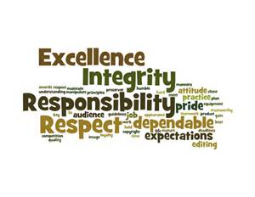
- Develop interview questions that will draw out core values

Sample Values List
Teamwork | Fairness & Compassion | Growth | Respect | Courage
Diversification | Innovation | Communication | Caring | Ethical
Loyal | Individuality | Passion | Safety | Integrity
Quality of Life | Supportive | Fostering | Fun | Fellowship
Hard Working | Trust | Honesty | Civility | Humorous
Athletic | Educated | Inspiring | Optimistic | Adventurous
Quality | Accountable | Resourceful | Leadership | Humble
Integration | Positive | Open-minded | Reliable | Punctual

Guiding principles
- Are short phases that support the core values
- Provide direction or guidance to employees on how to act/behave
- Allow employees to make easier decisions on behalf of the company
- Make Every Customer Feel Valued
- Drive for Excellence
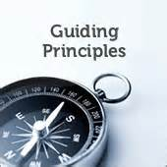
- Safety First and Last
- Do the Right Thing
- Don’t Take the Easy Way Out
- The Customer Comes First
- Global Perspective and Participation
- Quality Leadership
- Walk the Talk
- Mistakes Are Learning Opportunities
- Measure Twice, Cut Once
- Deliver WOW Through Service
- Embrace & Drive Change
- Be Humble
- Create Fun and a Little Weirdness
- Work Life Integration
- Be Adventurous & Creative
- What Got Us Here Isn’t Going to Get Us There

vision statement
- Answers the question “What do we want to become?”
- Provides the organization with a forward looking ideal image of itself and its uniqueness
- Is an end state – not how to get there
- Provides a common vision and sense of teamwork
- Uses words such as “to be” or “establish”
- Is long term (5+ years)
- Every word in the vision statement should have value, supports an image, inspires and isn’t vague
- Reaches for the sky, but is still realistic
- Creates meaning & purpose
- Should be short enough that you don’t need to take a breath
- Should be unique to the company
- The intent is for it to be used internally and not as a marketing tool
- Less “slogan based”
- Vision statements usually change when there is a major shift in the direction of the company (ie new leadership/board of directors)

Mission Statement
- Is the reason that an organization exists and what it will do
- Is internal
- Is congruent with the organization’s core values
- Is revisited every 2-3 years
- Answers
  - What function do we perform?
  - For whom do we perform it?
  - How do we go about filling this function?
  - Why do we exist?
- Is short (can be memorized)
- Make it simple (use everyday language)
- Is operative (3 verbs maximum)
- Clearly defines what you do and don’t do

Financial Evaluation
- Key Questions
- I know on average how much I make on each sale and record it
- I know how many sales, customers or $’s I need to break even
- I have a cash flow forecast for the business (12 weeks minimum)
- I generate monthly financials statements and I understand what they mean
- I budget for profit and have set regular profit goals
- I have strategies in place to increase my gross profit
- I set time aside at the end of each month to review my financial performance
- I have a current overhead budget in place
- I have a current marketing budget in place
- I have a forecast in place to help me predict what this year’s income will look like
- I regularly collect on my accounts receivable
- I am current on paying my accounts payable
- I am current with all my government filing and regulatory payments
- I have sufficient financial resources in place to manage cash flow risk
- I understand my exposure to business risk
- I have sufficient/efficient levels of inventory to support my business
- I have adequate business insurance in place

Environmental scan
- Purpose is to identify trends
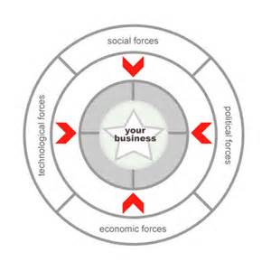
- It is not focused inward on your organization
- The focus is to look at what is going on around you
- Social, Political, Legal, Economic, Market, Competitors, Technical, Social
- Key Questions
  - What needs are being met?
  - What is the total volume in this market?
  - What is our share of the market?
  - How many total customers are there?
  - What is the potential for growth?
  - What recent events would affect the market?

SWOT Analysis
- The key is to be honest
- Looks at where the organization is today
- Come together to agree as a team
- Prioritize each of them

 | Helpful | Harmful
Internal | Strengths | Weaknesses
External | Opportunities | Threats

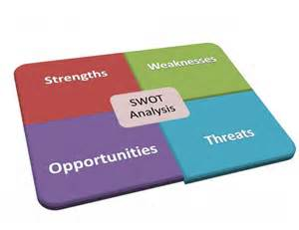
- Strengths
  - What do you do well?
  - What differentiates you from others that provide similar services?
  - Do you have sustainable staff?
  - What are your assets?
- Weaknesses
  - What could you improve on?
  - Where do you have fewer resources than others?
  - Do you lack any necessary expertise?
  - Do you have policies and procedures?
  - Do you depend too much on any one specific customer/individual?
  - Is your website/marketing effective?
- Opportunities
  - What opportunities are open to you?
  - What trends impact you the most?
  - Mergers/acquisitions?
  - Other products/services you can provide?
  - Other geographical locations?
  - Can we offer our existing programs to a different market?
- Threats
  - What is your competition doing?
  - Are there any 3rd parties that are critical to your process?
  - How might a natural disaster or epidemic impact your operation?
  - What threats could harm you?
  - Prioritize the threats by impact vs probability
  - Are there some programs that need to be cut?
- Key Questions/Statements
  - The business has defined customer service levels
  - Each customer receives the same experience
  - We regularly survey our customers
  - We have a script/process in place for greeting customers and answering the phone
  - We consistently brainstorm ways to exceed our customers’ expectations
  - We analyze our mistakes and put processes in place to ensure that they don’t happen again
  - The business has a meaningful guarantee in place
  - The team knows what our USP is (Unique Selling Point)
  - Our sales strategies promote our USP
  - We know what our target market is
  - We work with 3 non-competing alliances
  - We have a referral program in place
  - We consistently used different ways to generate business leads
  - The team uses sales scripts and processes that are documented
  - The sales team receives regular sales training
  - The sales team is accountable to deliver sales projections
  - The business has a database of clients and prospects
  - Our clients have been graded A,B,C or D
  - We know how to upsell our products
  - We continue to record and monitor the # of leads coming in
  - We know and understand our conversion rate
  - We are efficient in completing repetitive tasks
  - We have documented processes and flow charts
  - We have up-to-date computer software technology
  - We have an up-to-date inventory management system
  - Our payroll system is efficient and informative
  - All tasks that can possibly be automated have been
  - Our staff delegate effectively in a cost efficient manner
  - We schedule regular maintenance on all key items of equipment
  - Each team member understands their role and has a current job description
  - Each team member understands how their achievements will be measured
  - There is a current succession plan in place
  - We have a current organizational chart
  - We plan & prepare regular staff performance reviews
  - There is more than one strong leader in the team
  - Our culture has been identified and shared with the team
  - Each member of the team has their own 90 day goal plan
  - All team members are committed to playing “above the line”
  - I have a system for encouraging open communication
  - I trust my team and allow them the responsibility to make decisions
  - I have an organizational chart for what the business will look like in the future
  - I have an on-boarding process for new staff
  - I don’t have to be present in the business everyday
  - I have identified, groomed and appointed a general manager
  - I have a contingency plan in place for staffing
  - I have financial and personal independence
  - I am investing and growing assets outside my business
  - I am actively putting an exit strategy in place
  - The business is generating passive income
  - I am giving back to charity
  - I am mentoring others

Strategic Goals & Objectives
- Use your SWOT analysis to come up with ideas that can take your company to the next level
- Get all your ideas on the table
- Prioritize your goals
- Goals should be timely and quantifiable (SMART goals)
- Drill down to a department level and then an employee level
- Employees can be bonused or evaluated on completing their component of the action plan
- Each action item ties into a corporate KPI or metric
- Action plans can become enormous due to the economies of scale. There is a higher level of time commitment the more people involved and the higher the number of goals
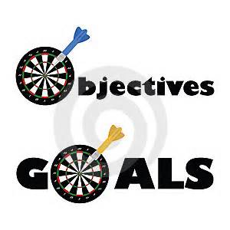
- Keep it simple and manageable
- Watch out for costs increases as new equipment/staff might be needed to support increased volume of business
- Goals should be evenly focused though all pillars of the business
  - Financial Success
  - Operational Excellence
  - Customer Satisfaction
  - Employee Satisfaction
  - Sales
  - Innovation/Creativity
- Try not to change more than one of the following:
  - Who (your customer or client groups)
  - What (your customer needs, products or services)
  - How (activities, technologies or methods of sale)

KPI’s (Key performance Indicators) or Metrics
- Usually represented in a chart format
- Includes measurement, current level, targeted level, Green/Yellow/Red status, Due Date, Comments or Clarification
- Are they realistic?
- Did you miss anything?
- Have your priorities changed?
- Evaluate the fit between the goals and the current business
- Is it going to change your culture? Do you want it to?
- Do you have enough resources available to execute the plan?
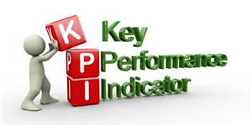

Implementation
- Budget rollout based on action items
- Your strategic plan can be developed into a business plan which can be used by 3rd parties and lenders
- Requires a communication plan to your team
- Can be used in conjunction with a performance management plan
- Supported through regular AGM’s or town hall meetings
- You can use posters or cards to convey values, principles etc.
- You can create a video to creates excitement for the staff
- Allocate sufficient time to working “on your business”
- Celebrate the successes throughout the implementation process
- Ensure that the timing of the action items are evenly distributed throughout the year. Tendency will be that everything is important which becomes overwhelming

Strategic Plan Format (Putting it All Together)
- Executive Summary (1-2 pages)
  - Vision
  - Mission
  - Values
  - Guiding Principles
  - Goals
  - KPI’s
- Current Assessment (5-8 pages)
  - Background Info
  - Financial Evaluation
  - Environmental Scan
  - SWOT Analysis
  - Product Life Cycle
  - Brains Storming Data
  - Current 5 Legged Chair Analysis
- Strategic Business Model (3-6 pages)
  - Detailed Action Plan
  - KPI Matrix
  - Correlating Budget
  - Marketing Budget
  - Communication Plan
  - Performance Management Plan

